PROGRAMMING WITH PYTHON SUBJECT CODE : 202044504

DEPARTMENT OF INFORMATION TECHNOLOGY
SEMESTER 5

NAME :Kashak Kapatel
ENROLLMENTNO. : 12402080601060
BATCH : IT_A 1C8 ACADEMIC YEAR :2026-27

Github Link :

ASSIGNMENT-2
PROBLEM STATEMENT 1: Given a large text file containing noisy text, extract all valid email addresses whose top-level domain is com, edu or org. Username may contain letters, digits, plus, dot, underscore or hyphen. For each domain, print the number of unique users and the lexicographically smallest email. Invalid emails must be ignored.

CODE :
import re
from collections import defaultdict

def main():
filename = input("Enter text file path: ").strip()
pattern = re.compile(r'(?<![\w.+-])[\w.+-]+@[\w.-]+\.(?:com|edu|org)\b') emails = defaultdict(set)
try:
with open(filename, encoding="utf-8") as f: for line in f:
for email in pattern.findall(line): domain = email.split("@", 1)[1] emails[domain].add(email)
for domain in sorted(emails): values = sorted(emails[domain])
print(domain, len(values), values[0])

except FileNotFoundError: print("File not found.")

if name == "main": main()

OUTPUT :
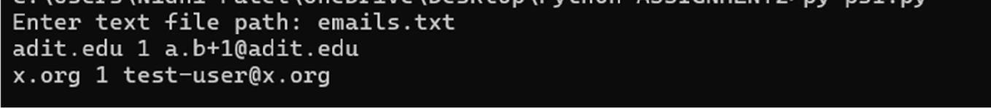

PROBLEM STATEMENT 2: You are given multiple saved HTML pages of product listings. Extract product name, price and rating from each page using regular expressions or an HTML parser. Normalize prices, remove duplicate products by name, and print the top K products with highest rating; ties are broken by lower price and then lexicographic product name.

CODE :
import re import os

def read_products(filename):
with open(filename, encoding="utf-8") as f: html = f.read()
pattern = re.compile( r'<h2[^>]*>(.*?)</h2>.*?'
r'class=["\'][^"\']*price[^"\']*["\'][^>]*>(.*?)</[^>]+>.*?'
r'class=["\'][^"\']*rating[^"\']*["\'][^>]*>(.*?)</[^>]+>', re.I | re.S
)

products = []
for name, price, rating in pattern.findall(html): name = re.sub(r"<[^>]+>", "", name).strip()
price = float(re.sub(r"[^\d.]", "", price))
rating = float(re.sub(r"[^\d.]", "", rating)) products.append((name, price, rating))
return products def main():
try:
p, k = map(int, input().split()) products = {}

for _ in range(p):
filename = input().strip()
if not os.path.isfile(filename): print("File not found:", filename) return
for name, price, rating in read_products(filename): if name not in products or (rating, -price) > ( products[name][1], -products[name][0]

):
products[name] = (price, rating)

result = sorted( products.items(),
key=lambda x: (-x[1][1], x[1][0], x[0])
)[:k]
for name, (price, rating) in result:
price = int(price) if price.is_integer() else price print(name, price, rating)
except ValueError: print("Invalid input.")

if name == " main ": main()

OUTPUT :
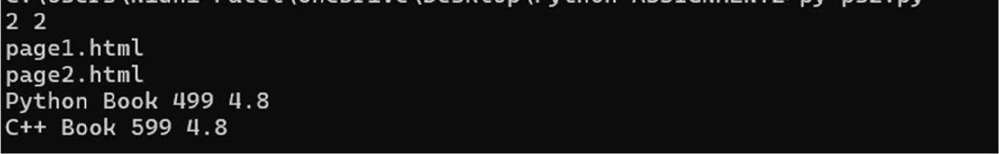

PROBLEM STATEMENT 3: Create a Python program that connects to a MySQL database, creates Student and Course Registration tables if they do not exist, inserts records from CSV files, and displays students registered for a given course with SPI greater than a threshold. Use parameterized queries and handle database exceptions.

CODE :
import csv
import mysql.connector

def connect():
return mysql.connector.connect( host="localhost", user="root",
password="YOUR_PASSWORD", database="college"
)

def create_tables(conn): cur = conn.cursor() cur.execute("""
CREATE TABLE IF NOT EXISTS Student(
student_id INT PRIMARY KEY, name VARCHAR(100) NOT NULL, spi DECIMAL(3,2) NOT NULL
) """)
cur.execute("""
CREATE TABLE IF NOT EXISTS CourseRegistration( student_id INT,
course_id VARCHAR(20),
FOREIGN KEY(student_id) REFERENCES Student(student_id)
) """)
conn.commit() cur.close()
def insert_students(conn, filename): cur = conn.cursor()
with open(filename, newline="", encoding="utf-8") as f: for row in csv.DictReader(f):
cur.execute(

"INSERT IGNORE INTO Student VALUES (%s,%s,%s)",
(row["student_id"], row["name"], row["spi"])
)
conn.commit() cur.close()
def insert_registrations(conn, filename): cur = conn.cursor()
with open(filename, newline="", encoding="utf-8") as f: for row in csv.DictReader(f):
cur.execute(
"INSERT INTO CourseRegistration VALUES (%s,%s)", (row["student_id"], row["course_id"])
)
conn.commit() cur.close()

def show_students(conn, course_id, threshold): cur = conn.cursor()
cur.execute("""
SELECT s.student_id, s.name, s.spi, r.course_id FROM Student s
JOIN CourseRegistration r ON s.student_id = r.student_id WHERE r.course_id = %s AND s.spi > %s
ORDER BY s.spi DESC, s.student_id ASC """, (course_id, threshold))
for row in cur: print(*row)
cur.close() def main():
student_file = input("Student CSV: ").strip() registration_file = input("Registration CSV: ").strip() course_id = input("Course ID: ").strip()

try:
threshold = float(input("SPI threshold: ")) if not 0 <= threshold <= 10:
raise ValueError

conn = connect() create_tables(conn)

insert_students(conn, student_file) insert_registrations(conn, registration_file) show_students(conn, course_id, threshold) conn.close()
except (ValueError, mysql.connector.Error, FileNotFoundError) as e: print("Error:", e)

if name == "main": main()

OUTPUT :
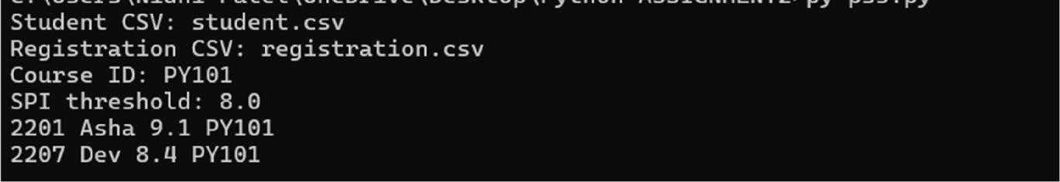

PROBLEM STATEMENT 4: Build a command-line query builder that receives filter conditions and generates safe parameterized SQL for joining Student, Course and CourseRegistration tables. It must support WHERE, ORDER BY, LIMIT and selected projection fields. Reject invalid columns and unsafe input before executing.

CODE :
import mysql.connector ALLOWED_COLUMNS = {
"student.id": "s.student_id", "student.name": "s.name",
"student.spi": "s.spi",
"course.id": "c.course_id", "course.name": "c.course_name"
}

def build_query(columns, filters, order_column, direction, limit):
if not columns or any(c not in ALLOWED_COLUMNS for c in columns): raise ValueError("Invalid column")
if order_column not in ALLOWED_COLUMNS: raise ValueError("Invalid order column")
if direction.upper() not in ("ASC", "DESC"): raise ValueError("Invalid sort direction")

if not 1 <= limit <= 1000:
raise ValueError("Invalid limit")
selected = ", ".join(ALLOWED_COLUMNS[c] for c in columns) query = f"""
SELECT
{selected} FROM Student s
JOIN CourseRegistration r ON s.student_id = r.student_id JOIN Course c ON r.course_id = c.course_id
"""

params = [] if filters:
conditions = []
for column, operator, value in filters:

if column not in ALLOWED_COLUMNS: raise ValueError("Invalid filter column")
if operator not in ("=", ">", "<", ">=", "<=", "LIKE"): raise ValueError("Invalid operator")
conditions.append(f"{ALLOWED_COLUMNS[column]} {operator} %s") params.append(value)
query += " WHERE " + " AND ".join(conditions)

query += f" ORDER BY {ALLOWED_COLUMNS[order_column]} {direction.upper()}" query += " LIMIT %s"
params.append(limit) return query, params
def
main():
try:
columns = input("Columns: ").split(",") columns = [c.strip() for c in columns]
filters = []
text = input("Filter (column,operator,value) or blank: ").strip()

if text:
column, operator, value = map(str.strip, text.split(",", 2)) filters.append((column, operator, value))
order_column = input("Order column: ").strip() direction = input("Direction: ").strip()
limit = int(input("Limit: "))

query, params = build_query(
columns, filters, order_column, direction, limit
)

print("SQL_OK") print(query) print("Parameters:", params)
conn = mysql.connector.connect( host="localhost",
user="root",

password="YOUR_PASSWORD",database="college"
)
cur = conn.cursor() cur.execute(query, params)
for row in cur: print(*row)
cur.close() conn.close()

except (ValueError, mysql.connector.Error) as e: print("Error:", e)
if name == "main": main()

OUTPUT :
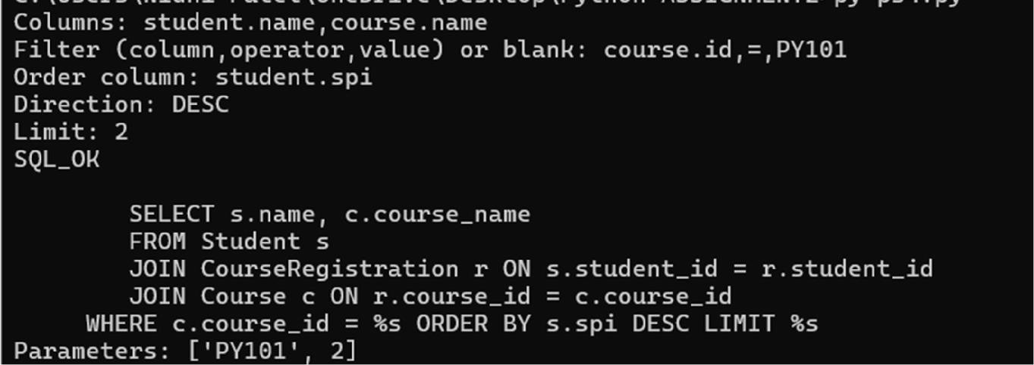

PROBLEM STATEMENT 5: Develop a Tkinter contact manager that stores contacts in MySQL. It must support create, update, delete, search by name/email/phone, and sorted display. Use Entry, Text, Radio Button or Check Button, Listbox/Menu and Combobox widgets. Validate email using regex before insert/update.

CODE :
import tkinter as tk
from tkinter import ttk, messagebox import sqlite3
import re

def connect():
return sqlite3.connect("contacts.db")

def setup():
conn = connect() conn.execute("""
CREATE TABLE IF NOT EXISTS Contact(
id INTEGER PRIMARY KEY AUTOINCREMENT, name TEXT NOT NULL,
email TEXT UNIQUE NOT NULL,
phone TEXT, category TEXT, notes TEXT
) """)
conn.commit() return conn

class App:
def init(self, root): self.root = root self.root.title("Contact
Manager") self.conn = setup()
labels = ["Name", "Email", "Phone", "Category", "Notes"] self.entries = {}
for i, label in enumerate(labels):
tk.Label(root, text=label).grid(row=i, column=0, padx=5, pady=5)

if label == "Category": entry = ttk.Combobox(
root,
values=["Faculty", "Student", "Friend", "Other"], width=32
)
else:
entry = tk.Entry(root, width=35)
entry.grid(row=i, column=1, padx=5, pady=5) self.entries[label] = entry

tk.Button(root, text="Add", command=self.add).grid(row=5, column=0, padx=5) tk.Button(root, text="Update", command=self.update).grid(row=5, column=1, padx=5) tk.Button(root, text="Delete", command=self.delete).grid(row=5, column=2, padx=5) tk.Button(root, text="Search", command=self.search).grid(row=5, column=3, padx=5) tk.Button(root, text="Show All", command=self.show_all).grid(row=5, column=4, padx=5)

self.listbox = tk.Listbox(root, width=100, height=15) self.listbox.grid(row=6, column=0, columnspan=5, padx=5, pady=10) self.show_all()
def get_values(self): return (
self.entries["Name"].get().strip(),
self.entries["Email"].get().strip(),
self.entries["Phone"].get().strip(),
self.entries["Category"].get().strip(),
self.entries["Notes"].get().strip()
)
def valid_email(self, email):
return re.fullmatch(r"[\w.+-]+@[\w.-]+\.[A-Za-z]{2,}", email)

def add(self):
name, email, phone, category, notes = self.get_values()

if not name or not email:
messagebox.showerror("Error", "Name and Email are required") return

if not self.valid_email(email): messagebox.showerror("Error", "Invalid email") return

try:
self.conn.execute(
"INSERT INTO Contact(name,email,phone,category,notes) VALUES(?,?,?,?,?)", (name, email, phone, category, notes)
)
self.conn.commit() self.clear() self.show_all()
messagebox.showinfo("Success", "Contact added") except sqlite3.IntegrityError:
messagebox.showerror("Error", "Email already exists")
def update(self):
selected = self.listbox.curselection()

if not selected:
messagebox.showerror("Error", "Select a contact") return
name, email, phone, category, notes = self.get_values() if not self.valid_email(email):
messagebox.showerror("Error", "Invalid email") return
contact_id = self.listbox.get(selected[0]).split("|")[0].strip() try:
self.conn.execute( """UPDATE Contact
SET name=?, email=?, phone=?, category=?, notes=? WHERE id=?""",
(name, email, phone, category, notes, contact_id)
)
self.conn.commit() self.clear() self.show_all()
messagebox.showinfo("Success", "Contact updated")

except sqlite3.IntegrityError: messagebox.showerror("Error", "Email already exists")
def delete(self):
selected = self.listbox.curselection()

if not selected:
messagebox.showerror("Error", "Select a contact") return
contact_id = self.listbox.get(selected[0]).split("|")[0].strip() self.conn.execute(
"DELETE FROM Contact WHERE id=?",
(contact_id,)
)
self.conn.commit()

self.clear() self.show_all()
messagebox.showinfo("Success", "Contact deleted")

def search(self):
term = self.entries["Name"].get().strip()

rows = self.conn.execute(
"""SELECT id,name,email,phone,category FROM Contact
WHERE name LIKE ? OR email LIKE ? OR phone LIKE ? ORDER BY name""",
(f"%{term}%", f"%{term}%", f"%{term}%")
).fetchall() self.display(rows)
def show_all(self):
rows = self.conn.execute(
"""SELECT id,name,email,phone,category FROM Contact
ORDER BY name"""
).fetchall() self.display(rows)

def display(self, rows): self.listbox.delete(0, tk.END) for row in rows:
self.listbox.insert(tk.END, " | ".join(map(str, row)))

def clear(self):
for entry in self.entries.values(): entry.delete(0, tk.END)

root = tk.Tk() App(root) root.mainloop()

OUTPUT :
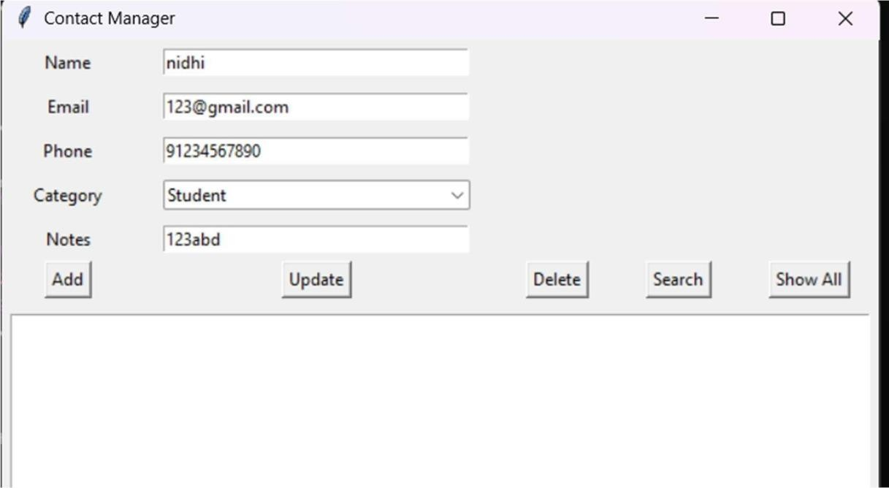

PROBLEM STATEMENT 6: Given timestamped application logs, detect every user who has at least X failed login attempts within any T-minute window followed by a successful login from a different IP address. Use regex to parse log lines and an optimized sliding window per user.

CODE :

import re
from collections import defaultdict, deque

def to_minutes(t):
h, m = map(int, t.split(":")) return h * 60 + m
def
main():
try:
X, T = map(int, input().split()) n = int(input())
failures = defaultdict(deque) suspicious = {}

pattern = re.compile( r"^(\d{2}:\d{2})\s+(\S+)\s+(\S+)\s+(FAIL|SUCCESS)$"
)
for _ in range(n):
line = input().strip()
match = pattern.match(line)

if not match: continue
timestamp, user, ip, status = match.groups() current = to_minutes(timestamp)
if status == "FAIL": q = failures[user]
while q and current - q[0][0] > T: q.popleft()
q.append((current, ip))

else:q = failures[user]
while q and current - q[0][0] > T: q.popleft()
if len(q) >= X and any(old_ip != ip for _, old_ip in q): suspicious.setdefault(user, timestamp)

for user in sorted(suspicious): print(user, suspicious[user])
except ValueError: print("Invalid input.")
if name == "main": main()

OUTPUT :
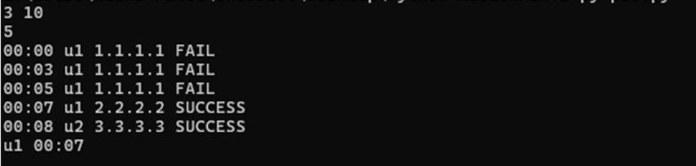

PROBLEM STATEMENT 7: Create an ETL pipeline using generator functions that reads a large JSON-lines file of sensor records, filters corrupted records, transforms units, groups readings by device and produces summary statistics. The program must not load the full file into memory.

CODE :
import json
from collections import defaultdict
def read_records(filename):
with open(filename, encoding="utf-8") as f: for line in f:
try:
yield json.loads(line)
except json.JSONDecodeError: yield None
def main():
filename = input("Enter JSONL file path: ").strip() data = defaultdict(lambda: {
"count": 0,
"min": float("inf"),
"max": float("-inf"), "sum": 0.0,
"corrupted": 0
})

try:
for record in read_records(filename): if not isinstance(record, dict):
continue

device = record.get("device_id") temperature = record.get("temperature_c")

if not device or not isinstance(temperature, (int, float)): if device:
data[device]["corrupted"] += 1 continue
d = data[device]

d["count"] += 1
d["min"] = min(d["min"], temperature)
d["max"] = max(d["max"], temperature) d["sum"] += temperature

for device in sorted(data): d = data[device]
if d["count"]:
avg = d["sum"] / d["count"] print(
f"{device} count={d['count']} "
f"min={d['min']} max={d['max']} " f"avg={avg:.2f} corrupted={d['corrupted']}"
)
else:
print(f"{device} count=0 corrupted={d['corrupted']}")

except FileNotFoundError: print("File not found.")

if name == " main ": main()

OUTPUT :

PROBLEM STATEMENT 8: Given an n x m matrix of integers, find the maximum score path from top-left to bottom-right. You may move right, down or diagonally down-right. Some cells are blocked. Also print the number of distinct maximum-score paths modulo 1000000007.

CODE :
MOD = 1000000007 NEG = -10**30
def
main():
try:
n, m = map(int, input().split()) matrix = []

for _ in range(n):
row = input().split()

if len(row) != m: print("Invalid matrix.") return

matrix.append([
None if x == "X" else int(x) for x in row
])

if matrix[0][0] is None or matrix[n - 1][m - 1] is None: print("IMPOSSIBLE")
return

score = [NEG] * m ways = [0] * m

for i in range(n): new_score = [NEG] * m new_ways = [0] * m

for j in range(m):
if matrix[i][j] is None: continue
if i == 0 and j == 0:

new_score[j] = matrix[i][j] new_ways[j] = 1

continue
best = NEG count = 0
for pi, pj in ((i - 1, j), (i, j - 1), (i - 1, j - 1)): if pi < 0 or pj < 0:
continue
s = score[pj] if pi == i - 1 else new_score[pj] w = ways[pj] if pi == i - 1 else new_ways[pj]
if s > best: best = s count = w
elif s == best:
count = (count + w) % MOD
if best != NEG:
new_score[j] = best + matrix[i][j] new_ways[j] = count
score, ways = new_score, new_ways if score[m - 1] == NEG:
print("IMPOSSIBLE")
else:
print(score[m - 1], ways[m - 1] % MOD) except ValueError:
print("Invalid input.")

if name == "main": main()

OUTPUT :
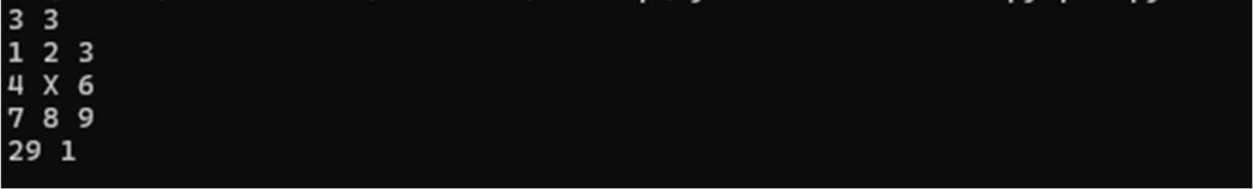

PROBLEM STATEMENT 9: Design Product and Inventory classes. Inventory must support adding products, deleting products, updating stock, comparing inventories by total value, and merging two inventories using operator overloading. Conflicting product ids must merge stock quantities but preserve the lower purchase price and higher selling price for reporting.

CODE :
class Product:
def init(self, pid, name, stock, purchase, selling): self.pid
= pid
self.name = name self.stock = stock self.purchase = purchase self.selling = selling
def value(self):
return self.stock * self.selling
class Inventory: def init(self):
self.products = {}
def add(self, product): self.products[product.pid] = product
def delete(self, pid): self.products.pop(pid, None)

def update(self, pid, stock): if pid in self.products:
self.products[pid].stock = stock

def total_value(self):
return sum(p.value() for p in self.products.values())

def add(self, other): result
= Inventory()
for p in self.products.values(): result.add(
Product(

p.pid, p.name, p.stock, p.purchase, p.selling)
)

for p in other.products.values(): if p.pid in result.products:
q = result.products[p.pid] q.stock += p.stock
q.purchase = min(q.purchase, p.purchase) q.selling = max(q.selling, p.selling)
else:
result.add( Product(
p.pid, p.name, p.stock, p.purchase, p.selling
)
)

return result

def gt(self, other):
return self.total_value() > other.total_value()

def display(self):
for p in sorted(self.products.values(), key=lambda x: x.pid): print(
f"{p.pid} {p.name} stock={p.stock} " f"purchase={p.purchase} selling={p.selling}"
)

def main():
a = Inventory()
b = Inventory()
n = int(input("Products in A: ")) for _ in range(n):
pid, name, stock, purchase, selling = input().split() a.add(Product(
pid, name, int(stock), float(purchase), float(selling)
))

n = int(input("Products in B: ")) for _ in range(n):
pid, name, stock, purchase, selling = input().split() b.add(Product(
pid, name, int(stock), float(purchase), float(selling)
))

while True:
command = input("Operation: ").strip().split()

if not command: continue

if command[0] == "ADD":
target = a if command[1] == "A" else b target.add(
Product(
command[2], command[3], int(command[4]), float(command[5]), float(command[6])
)
)
elif command[0] == "DELETE":
target = a if command[1] == "A" else b target.delete(command[2])

elif command[0] == "UPDATE":
target = a if command[1] == "A" else b target.update(command[2], int(command[3]))
elif command[0] == "MERGE": merged = a + b merged.display()
print("TOTAL", merged.total_value())

elif command[0] == "COMPARE": if a.total_value() >

b.total_value():
print("A")
elif b.total_value() > a.total_value():print("B") else: print("EQUAL")

elif command[0] == "EXIT": break
if name == "main": main()

OUTPUT :
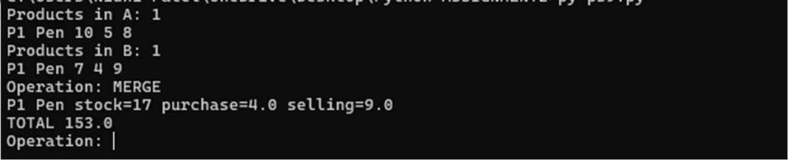

PROBLEM STATEMENT 10: Create a Python program that reads a CSV dataset of student marks, cleans missing values, calculates subject-wise statistics and exports at least three visualizations: grade distribution, subject-wise average comparison and top performer chart. The program may use matplotlib/pandas if permitted by faculty and must save charts as image files.

CODE :
import os
import pandas as pd
import matplotlib.pyplot as plt
def main():
filename = input("CSV file path: ").strip() output = input("Output folder: ").strip() try:
os.makedirs(output, exist_ok=True)
df = pd.read_csv(filename) subject_cols = list(df.columns[2:])

for col in subject_cols:
df[col] = pd.to_numeric(df[col], errors="coerce") df[col] = df[col].fillna(df[col].mean())
df.to_csv(
os.path.join(output, "cleaned_marks.csv"), index=False
)

summary =
pd.DataFrame({ "subject": subject_cols,
"average": [df[c].mean() for c in subject_cols], "minimum": [df[c].min() for c in subject_cols], "maximum": [df[c].max() for c in subject_cols]
})
summary.to_csv(
os.path.join(output, "summary.csv"), index=False
)

grades = pd.cut(df[subject_cols].mean(axis=1), bins=[-1, 40, 50, 60, 70, 80, 90, 100], labels=["F", "D", "C", "B", "A", "A+", "O"]
)

grades.value_counts().sort_index().plot(kind="bar") plt.xlabel("Grade")
plt.ylabel("Students") plt.tight_layout() plt.savefig(os.path.join(output, "grade_distribution.png")) plt.close()
summary.plot( x="subject", y="average", kind="bar", legend=False
)
plt.ylabel("Average Marks") plt.tight_layout()
plt.savefig(os.path.join(output, "subject_average.png")) plt.close()
df["average"] = df[subject_cols].mean(axis=1) top = df.nlargest(5, "average")
plt.bar(top["name"],
top["average"]) plt.xlabel("Student") plt.ylabel("Average") plt.xticks(rotation=30) plt.tight_layout()
plt.savefig(os.path.join(output, "top_performers.png")) plt.close()
print("cleaned_marks.csv") print("summary.csv") print("grade_distribution.png") print("subject_average.png") print("top_performers.png")
except FileNotFoundError: print("File not found.")

except Exception as e: print("Error:", e)

if name == "main": main()

OUTPUT :
